[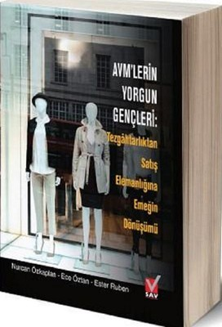](https://www.google.com/url?sa=i&url=https%3A%2F%2Fwww.dr.com.tr%2FKitap%2FAvmlerin-Yorgun-Gencleri%2FEgitim-Basvuru%2FIs-Ekonomi-Hukuk%2FSatis-Pazarlamahalkla-Iliskiler%2Furunno%3D0001738056001&psig=AOvVaw2PtsBvJ_gOg7B_st0vco4y&ust=1588842232644000&source=images&cd=vfe&ved=0CAIQjRxqFwoTCOiF3uDynukCFQAAAAAdAAAAABAD)